**USING RAPTOR –DISPLAY PRIME NUMBERS BETWEEN 1 AND 100**

**FLOWCHART**

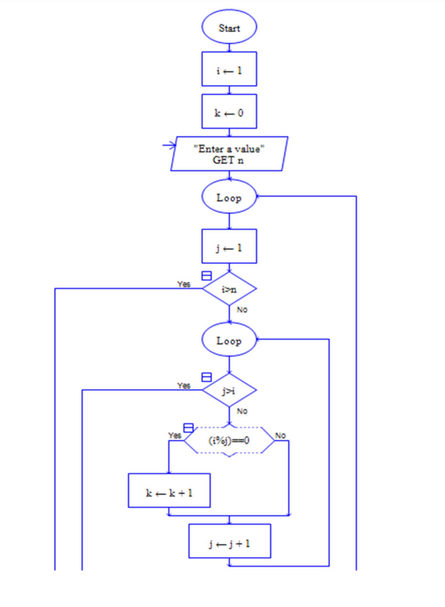

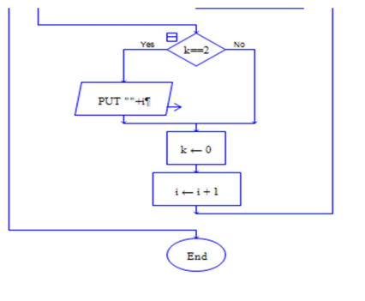

**INPUT**

100

**OUTPUT**

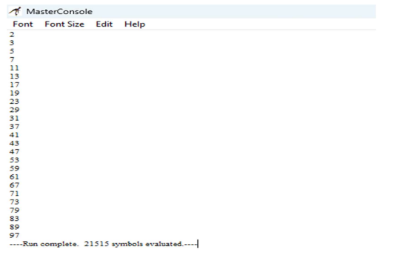

**RESULT:**

The program is executed and verified successfully